Help with Coding:

1. “If you have been asked to help a student learning about html, design a website using html and css. Please help them create a website with the structure shown in the attached image. Show and explain the code and separate the html and css”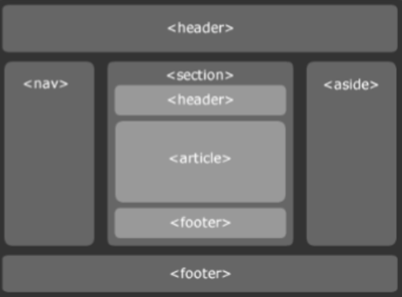
2. “If I'm trying to make the boxes in the nav section be vertical how would I do that?”
3. “How would I change my text from the aside part of the website?”
4. “How would I make the article and footer sections wider?”
5. “How do I insert a link to an email so it keeps the subject line?”

Help with Company Ideas:

1. “Can you come up with some ideas for an eco-friendly sneaker company?”
2. “Can you tell me more about EcoSoles?”
3. “Can you make up the history for EcoSoles such as when it was founded, by who, what products it sold in its early days, how it has grown over the years and more?”
4. “Could you come up with a couple logo ideas for EcoSoles?”
5. “Could you make the first one into a picture?
6. “Could you tell me about some of the employees from the company?”
7. “Can you give me some pictures of some of the products that ecosoles sells?”
8. “Could you just summarize both ideas into a short paragraph for each?”
9. “Could you summarize two more products, one being another outdoor shoe and the other being a hiking boot in a short paragraph each?”
10. “Can you come up with some financing policies for the company?”
11. “Can you come up with two delivery policies for the company?”
12. “Can you come up with a return policy for the company?”